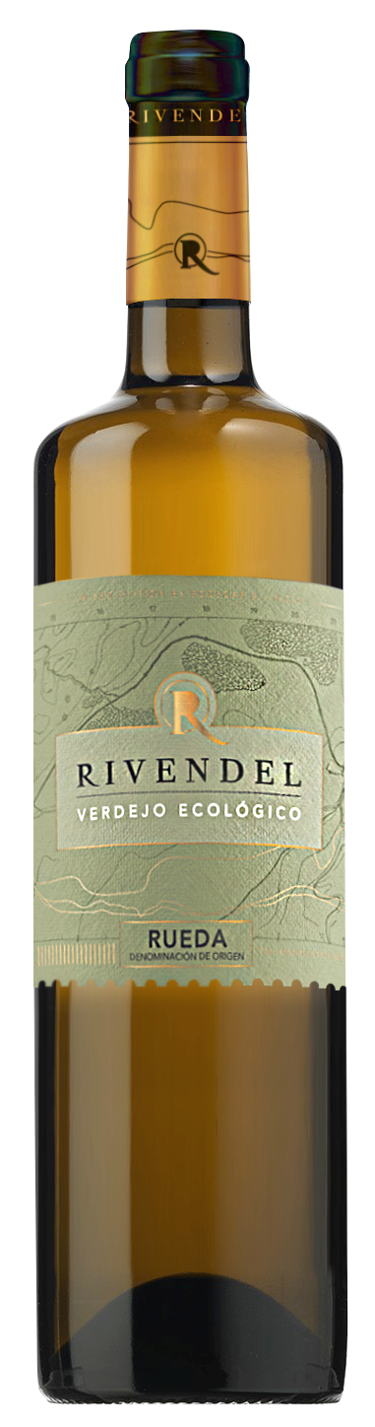

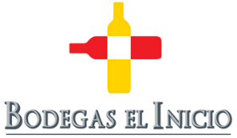
SanVicente 22 Street47300
Peñafiel(Valladolid)
Spain

Phone:+34 947515884
www.bodegaselinicio.com

ORGANIC VERDEJO
D.O. RUEDA

INFORMATION
Organic White Wine to be enjoyed during 4 years after the harvest.
Variety: Verdejo 100%.
From our own Organic Vineyards: Finca Los Caleros, located in Nava del Rey, Valladolid, Castilla y León.
Yield: 4.500 kg/ha. Stony, gravelly soils with an approximate height of 700 meters.
This wine has a new elaboration style, appreciated in tasting.

TASTING NOTES
Sight: bright, straw yellow colour with green glints.It has lot of glycerin tears.
Nose: fresh, high intensity with a lot of different hints, all of them perfectly integrated: white blossom, stone fruit, pear and minerality among other.
Mouth: fresh,full of sensations, with a very well-integrated acidity.At the beginning all the nose touches are present, adding high intensity and creaminess. Lingering.

Optimal serving temperature between 7 and 9 ºC.

ITS PARTICULAR ELABORATION
At the discretion of Angel Luis, Technical Director, 40% of the grapes spontaneously ferment in 500-litre French oak barrels and remain on their lees for 6 months. The remaining 60%, ferments in a stainless-steel tank as well and remains with the fine lees for 6 months.
The final coupage offers the typical freshness of Rueda wines together with a slight touch of wood that adds complexity on the palate that differentiates it from traditional wines.

